caBench-to-Bedside
Architecture

Document Change History
Version Number | Date | Contributor | Description
1.0 | 28th February 2007 | Washington University/Persistent Systems | In progress

Introduction
This document describes the architecture and high level design of caB2B application.
Salient features of the architecture:
Client server architecture: The necessity of the client-server architecture is driven by multiple requirements:
- Investigators can create experiments locally and associated saved query results and results from analytical services
- Ability to save results, query and views
- Asynchronous execution of tasks workflow jobs, time-taking queries or analytical services
- In memory caching of data for better performance
- Share data amongst researches within a lab
It is envisaged that there will be multiple investigators in a lab who will be using caB2B; so typically there would be one caB2B server amongst all the researchers a lab.
Metadata driven approach: One of the basic requirements for the caB2B design was that given a domain-extract.xml file of any application it should be possible to build a query for fetching data from that data source.
In order to understand the design of caB2B it is first necessary to understand the design and concept of the metadata repository (MDR). MDR is a repository within the caB2B local database which stores all the details of the UML model i.e. all CDEs including permissible values, all possible paths between all pairs of classes. This information is gotten by decomposing the annotated UML model along with details like concept codes and permissible values.
Due to this approach, end users need not bother about the details like associations within an UML model; they can add limits on any two classes and caB2B will execute the query as long as there exists at least one path between those two classes. Note that these two classes can be two classes within the same model or across different models.
caB2B can be either be configured to automatically fetch metadata for any new model from caDSR or the administrator can select the models to be loaded. For example, the administrator can decide to load the models pertaining to the kind of research done in that lab.
Given this approach we envisage the following scenario once caB2B is in production:
- caB2B server is installed in a lab with the client installed at multiple investigators’ desktop.
- caB2B server is configured to grab every new model from caDSR every night that has at least one data service registered in the index service.
- Therefore, caB2B can query any new grid data service as soon as they are up and running.
The goal of MDR is make the caB2B design completely redundant of any application-specific knowledge.

Refer to MetadataRepository_Design.doc document for design details of metadata repository (MDR).

caB2B Architecture
This section explains the caB2B client server architecture at a high level and also describes the main components in detail.
Client
Query UI

Experiment UI

Results Viewers

Metadata Search UI

Server

Query Engine

Metadata Search Engine

Data Cache

E
J
B

L
O
C
A
T
E
R
Async Job Manager

CQL Generator

Path Resolver

Metadata Loader

caGrid Service Locator

MDR
TMP
SC
EXP
Local database
SC: Static cache
EXP: Experiment data
MDR: Metadata repository
TMP: Temporary cache
Figure 1 caB2B: High level block diagram

Client Server communication
The caB2B client is a standalone Java Swing application and caB2B server is a J2EE server deployed on JBoss. Client- server communication happens through RMI-IIOP i.e. "Remote Method Invocation over the Internet Inter-ORB Protocol". EJB is a part of Java RMI-IIOP i.e. EJB is a remote object and is callable from a different JVM.
During server startup each EJB’s Home Object (i.e. factory for creating EJB instances) is tied with a name in JNDI (Java Naming and directory interface) tree on the same server. When client needs to call a method on server side code, it does following:
- It asks EJB-locator on client side to locate appropriate EJB instance that provides the required functionality. Each locator instance is aware of which JNDI tree to refer.
- Locator looks up the Home Object of corresponding EJB in JNDI tree and uses it to get EJB instance.
- UI then calls the required method on EJB instance.
Refer to ClientServer_Communication_design.doc document for design details of client-server communication

Metadata Repository (MDR)
The domain-extract.xml is downloaded from the caDSR, decomposed and loaded into the MDR in the local database. The MDR is reused across multiple projects in Wash U is explained in detail in a separate design document which can be found in MetadataRepository_Design.doc document.

Category (pseudo Class)
Exposing the classes in an UML model will not make much sense to a biologist end user. This is because UML model is not a true reflection of the domain problem; developers end up doing a lot of optimizations like inheritance, reusable associated classes and so forth. For example, in caTissue Core participant class does not contain the medical identifiers attributes. However for the end user biologist, medical identifiers are part of the participant data. To solve this problem, we came with the concept of a Category which is a logical collection of attributes from different classes, within or across UML models, in such a manner that it makes most sense to the end users.
A Category is a treated similar to a class i.e. collection of attributes. The only additional information stored is the path between the attributes within a class. This information is needed to perform the queries.
Categories are created by administrators and there will not be any user interface to create categories.
NOTE: Henceforth in this document category and classes might be used interchangeably where both of them refers to a logical collection of attributes.

Metadata search
Considering that end users are not familiar with the object models there should be a way for them to first search for the category/attribute on which they want to search. For example, an end user will not know which class has the attribute for clinical diagnosis in the caTissue object model. The metadata search allows the users to first search for category or attributes based on metadata like names, permissible values, definition based on text or concept code.
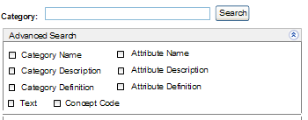
The search will always return the category/class which matches the search parameters. Examples of the metadata search:
- Category name is Specimen
- Attribute name contains tissue
- Permissible value contains “left kidney”
NOTE: All the following searches will return Specimen class of caTissue Core

Figure 2: Metadata based search

Query interface
Query interface provides the interfaces used to represent a user-defined query. The topmost unit is the IQuery. It contains the constraints and the outputs. The constraints are a combination of expressions and a join graph. Each expression belongs to an entity, and contains rules or expressions connected by logical connectors. The join graph contains the associations between the expressions. A tree represents the outputs.
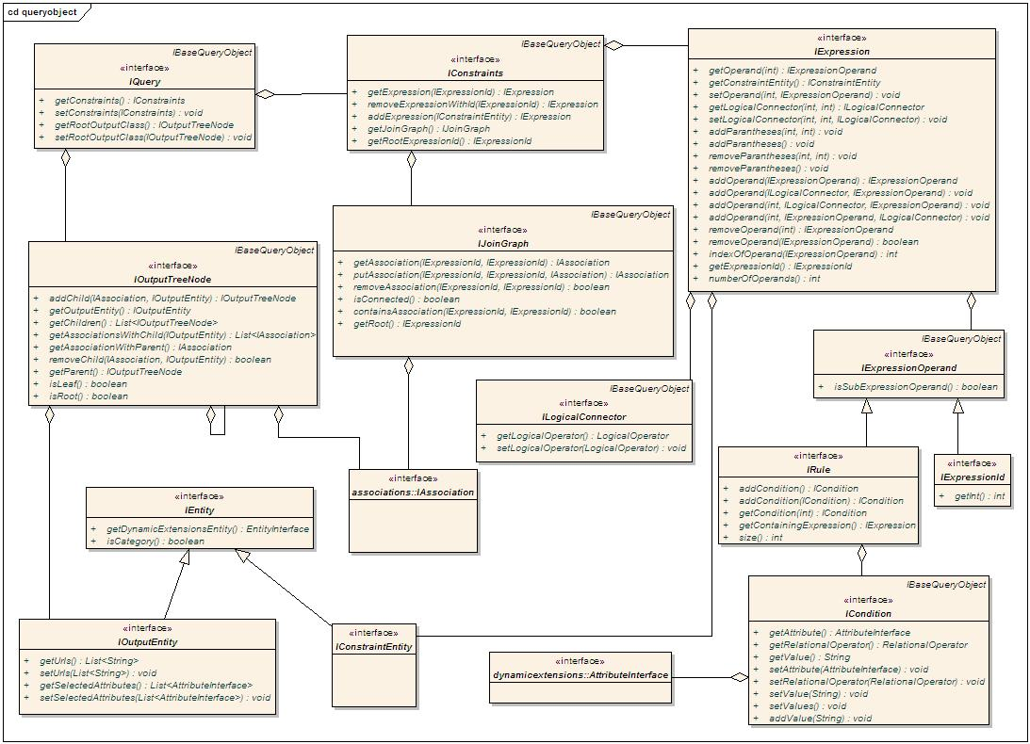

Interface Summary
ICondition | A condition containing an attribute, relational operator and value(s). E.g. participant.sex = 'Male'
IConstraintEntity | An entity that is associated with a constraint
IConstraints | Contains information about the constraints of a query. It contains a list of IExpressions that is indexed by IExpressionId. This is global storage location for all expressions in a query. Only calling the addExpression method here can create an IExpression. It also contains a join graph for specifying how the expressions are linked together.
IExpression | A list of operands, and the logical connectors (AND, OR) together form a logical expression. The connectors are identified by the position of the operands on either side. An IExpression belongs to a constraint entity and constraints on another associated entity will be present as a sub expression on the associated entity. Conversely, if an expression has a sub expression, there must an association in the join graph from the parent expression to the sub expression.  Note: "sub expression" refers to an operand that is the IExpressionId of the child expression. The entity of the sub expression will generally be different from the entity of this expression (exception is when a class is associated to itself, e.g. Specimen). The expression for an ExpressionId is found from IConstraints.
IExpressionId | An immutable wrapper around int used to uniquely identify an expression within a query. It is auto generated when an expression is added to a query.
IExpressionOperand | A marker interface for an operand. An operand is either a sub expression (in which case, the corresponding expression id is added), or a rule.
IJoinGraph | A rooted, directed acyclic graph with expressions as vertices, and associations as edges. The graph will always contain all the expressions' ids (obtained from IConstraints) as vertices. The vertices will be added to/removed from the Joingraph as and when expressions are added to/removed from IConstraints. The methods in Joingraph can only add/remove associations among the vertices.  If v1 and v2 are two vertices, the direction will be v1->v2 if v2 is a sub expression of v1. The user of the API will generally build the joingraph based on metadata, and in cases of ambiguity, the user will help forming this graph. This graph basically determines the join conditions in the query. E.g. for each edge (v1, v2) between two vertices v1 and v2, there will be a join between the functional classes of the expressions denoted by v1 and v2; and the join condition is determined by the info in the IAssociation.
ILogicalConnector | Represents a logical connector (AND / OR). The nesting represents the number of parentheses (depth of parentheses) around the logic portion (AND or OR) of the connector.
IOutputEntity | An entity associated with the output tree node.
IOutputTreeNode | A tree node to represent an output entity that is a part of the outputs of the query. It is a tree with vertex as IOutputEntity and edge as IAssociation. E.g. if a node with entity Participant has a child node with entity Specimen, it means "select participants, and associated specimens"; the association is as given by the label on the edge.  Note: The same entity can be present multiple times in this tree.  Thus, we can say "select specimens, and the available and used quantities of the specimens". Here, Specimen is parent, with two children; both children are the class Quantity, but the associations are different (available and used quantities).
IQuery | The query object. This is the unit built from UI, persisted, and from which queries will be built.
IRule | A list of conditions, on different attributes of an Entity.  Note: The conditions in a rule are implicitly linked by AND condition.

DCQL Generator
The DCQL generator currently supports a single output class.
Input : IQuery, OutputClassUrls
Output : DCQL

The DCQL is formed in the following manner:
- Starting with the root IExpression.
- Group or Attribute corresponding to each rule in the expression is formed. Also, parentheses are converted to appropriate Group’s.
- If the expression has a sub-expression operand, then an Association or ForeignAssociation is formed based on the association linking the classes of the parent and child expression respectively. This association is obtained from IJoinGraph.
- Constraints for the sub-expression are formed by recursively calling step 2. Add the constraints thus formed to the Association or ForeignAssociation. (The recursion terminates when an IExpression with no sub-expressions is encountered).
- Once step 4 is complete, we have the DCQL constraint (Group or Attribute) corresponding to each IExpression in the query.
- The targetObject of the DCQL is created corresponding to the output (set in IOutputTreeNode). The service URLsthat are provided as input are set in the targetObject. The constraints for this output class (formed by end of step 4) are set in the targetObject.

The DCQL thus formed is executed using the caGrid FQP. The results are returned to be displayed on the UI.

Things to do:
- Support for categories
- Support for multiple outputs:
  - Determine associations among records of the output classes.
  - Store the data for each class/category locally in database.
  - Provide methods that query this locally stored data (for traversing the results).

Path Generation
A path is ordered list of association between any two classes. caB2B pre-calculates the path between each two class in the UML model and stores in the MDR. This means that the end users need not bother about whether there is an association between the two categories on which there are rules.

Path generation involves following:
- caB2B server gets domainModel.xml for the registered applications, converts it to objects using standard caGrid APIs.
- Those objects are stored to database along with concept code and concept definition.
- Paths between all pairs of classes from that model are pre-calculated and stored to database.
- Direct associations (called InterModelAssociations) among the classes from different models are stored. Classes from different applications are connected based on their attribute’s CDE match. It involves matching the concept codes of the classes and their attributes in order.

Class/method details:
<TBD: minor change due to implementation of categories>

Results viewers
A simple results view comprising of a simple web-browser-like browsing capabilities i.e. browse from a returned object to its associated object (similar to Google search results). In this case, the user selects a starting category/class and then traverses through associated classes.
An advanced results view comprising of a hierarchical (tree) representation of the data on the left hand side, and a spreadsheet data on the right hand side. The classes in the tree and the attributes in the spreadsheet are both fully configurable. For example, the user can form a query on the Participant class (say, female participants with age greater than forty years) and form a tree comprising of Participant and Specimen classes as nodes in the results view.
This will enable caB2B to find the paths between two classes on which the user has entered rules. In case, there are ambiguous paths i.e. more than one paths the user will be presented the choice to select none, one or more, all paths to be included in the final query.
<incomplete>

